AI ASSISTANT CODING
ASSIGNMENT-24

NAME: THRISHALA JAKKARAJU
HALLTICKET:2303A51514
BATCH:22
Task 1 – Environment Setup
• Create a free Replit account.
• Explore the mobile app development templates (React Native
/ Flutter / HTML5 hybrid).
• Install required packages or dependencies in the Replit environment.
Prompt:-
development templates like React Native, Flutter, and HTML5. After selecting a suitable template, I set up the workspace and installed the required packages. This step helped me understand how the development environment works. It also ensured that everything was ready before starting the actual app development.
Output:-
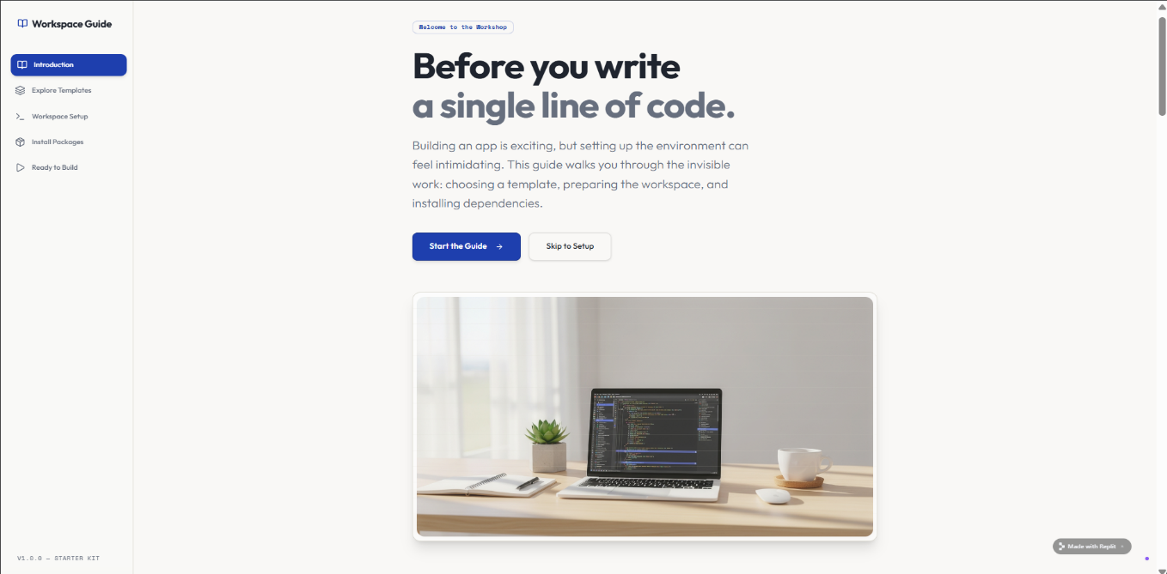
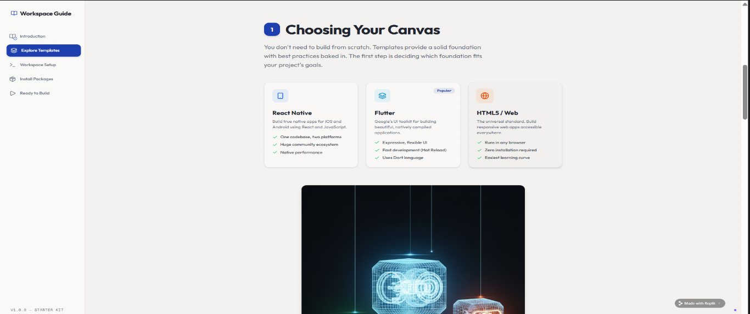

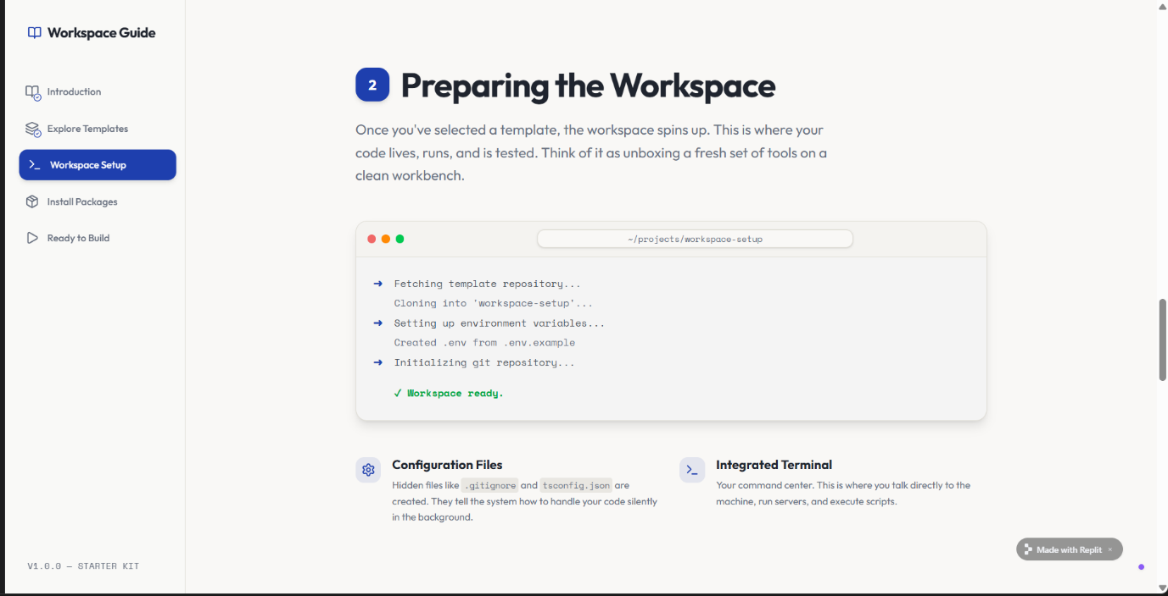
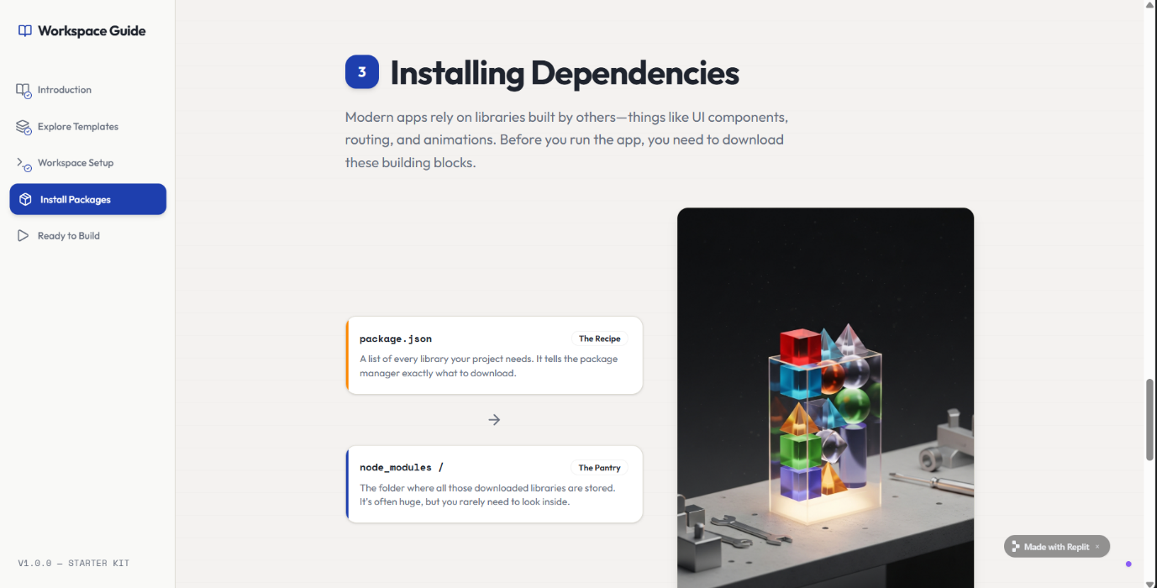
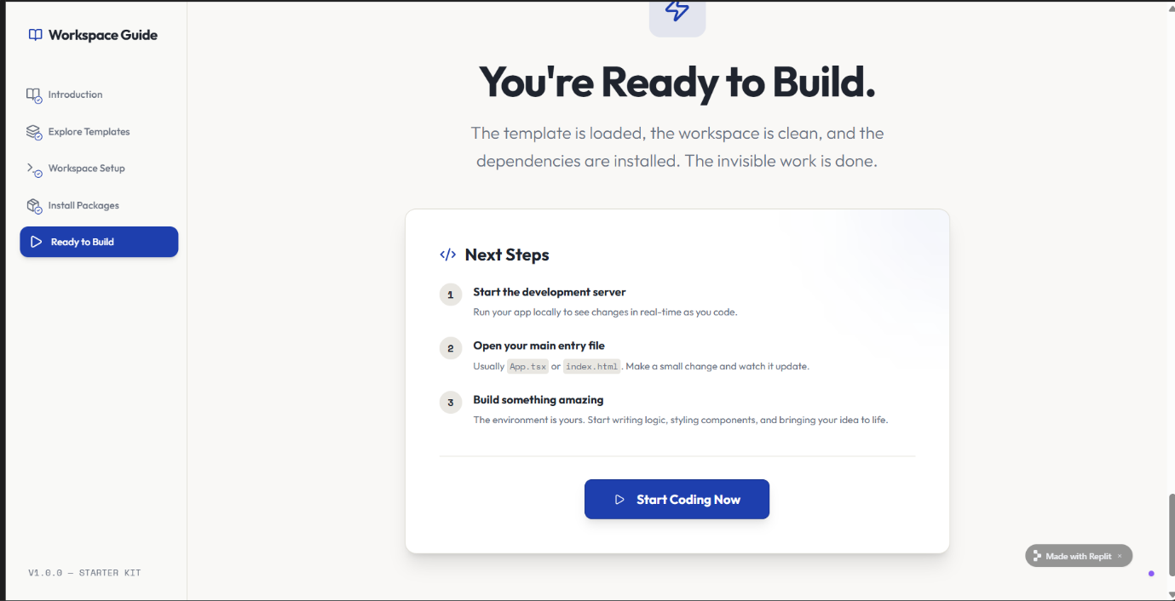

Task 2 – Basic Mobile App
• Build a simple "Hello App" that displays:
o App Title
o User’s Name (input field + button)
o Greeting message dynamically updated.
• Use AI assistance to generate boilerplate code and explain structure.
Prompt:-
developed a simple “Hello App” that displays the app title along with an input field for the user’s name. A button was added to generate a greeting message dynamically based on the input. This task helped me understand how user input works and how data can be displayed in real time. The structure of the app was kept simple for better clarity.
Output:-
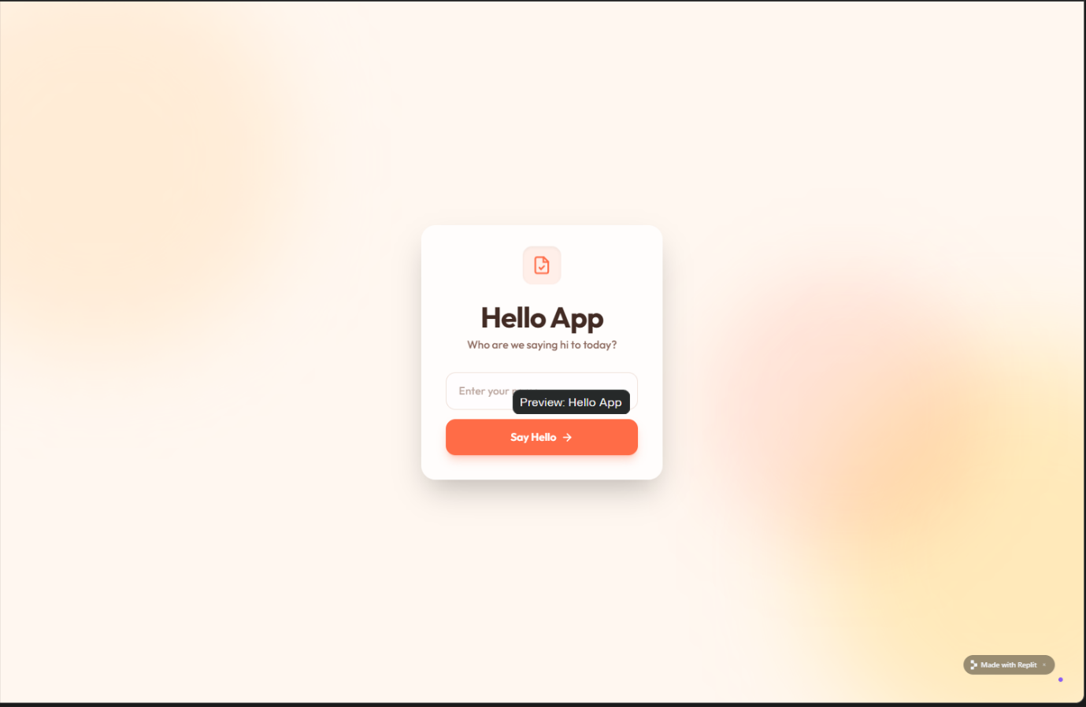

Task 3 – Adding Features with AI Assistance
• Enhance the app with:
o Navigation bar (Home, About, Contact).
o Form handling (e.g., user registration page).
o Basic styling with CSS or React Native styles.
• Ask AI in Replit to add inline documentation for each function.
Prompt:-
enhanced the app by adding a navigation bar with pages like Home, About, and Contact. I also created a basic user registration form with simple validation. To improve the appearance, I applied basic styling to the app. Additionally, I included inline comments in the code to make it easier to understand each function.
Output:-
Home Page:
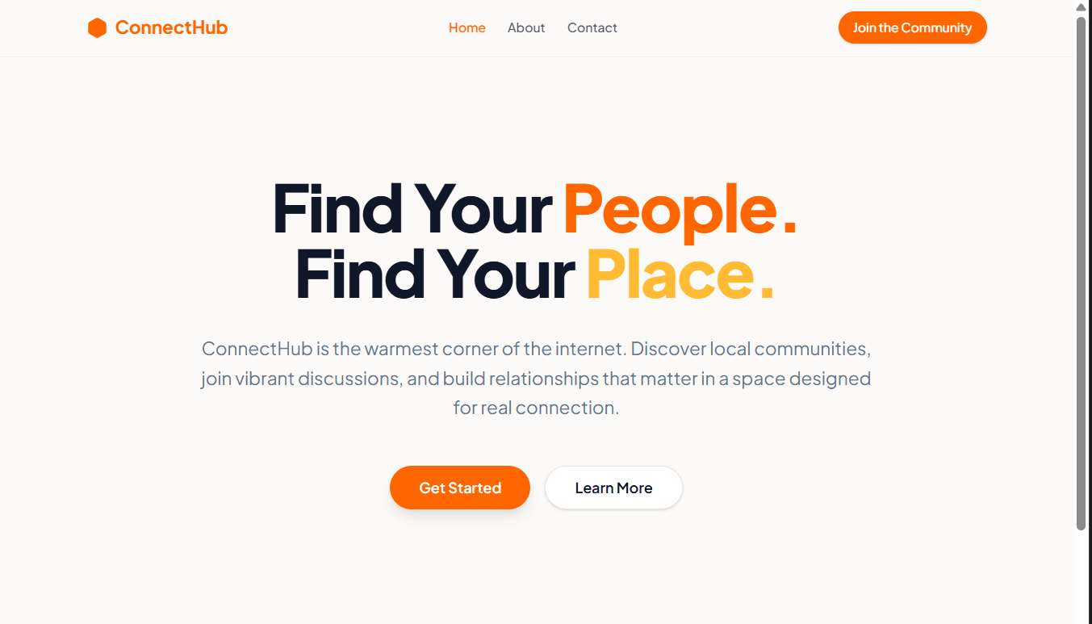
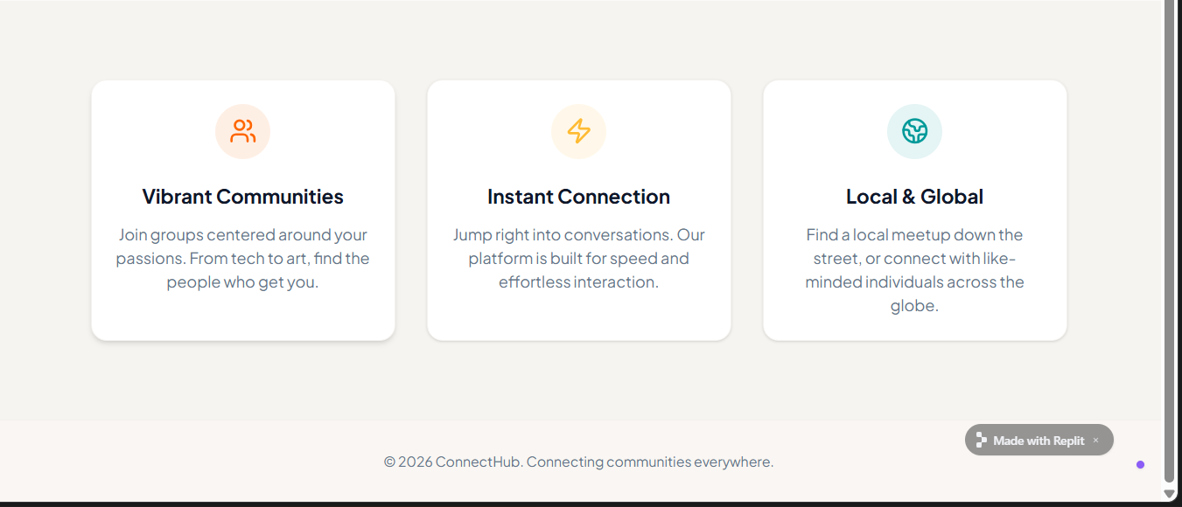

About page:
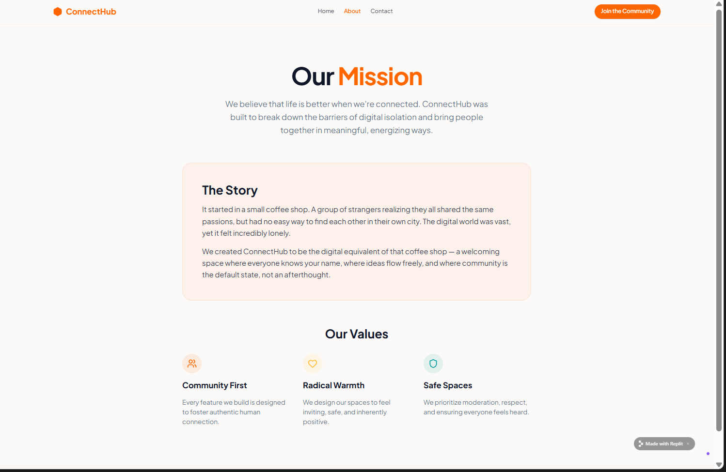

Contact Page:
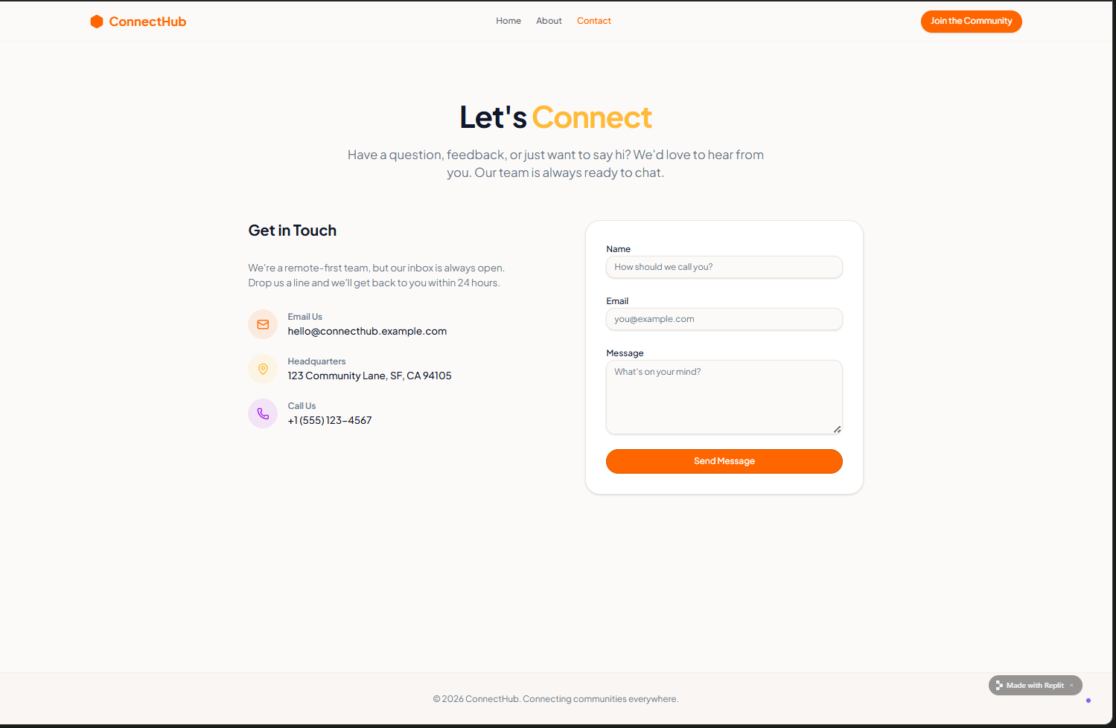
Registration Page:
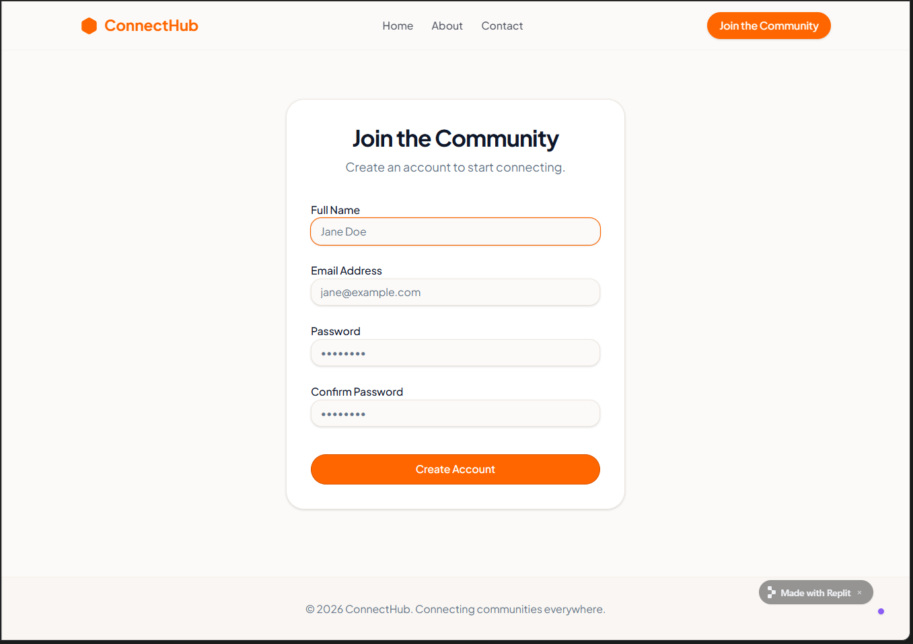

Task 4 – Testing on Mobile
• Run the app in Replit’s mobile preview mode.
• Test responsiveness on different screen sizes.
• Fix UI alignment issues with AI suggestions.
Prompt:-
building the features, I tested the app using Replit’s mobile preview mode. I checked how the app looked on different screen sizes and made sure all elements were properly aligned. Some minor UI issues were identified and fixed with the help of AI suggestions. This step ensured that the app runs smoothly on mobile devices.
Output:-
Home Page:
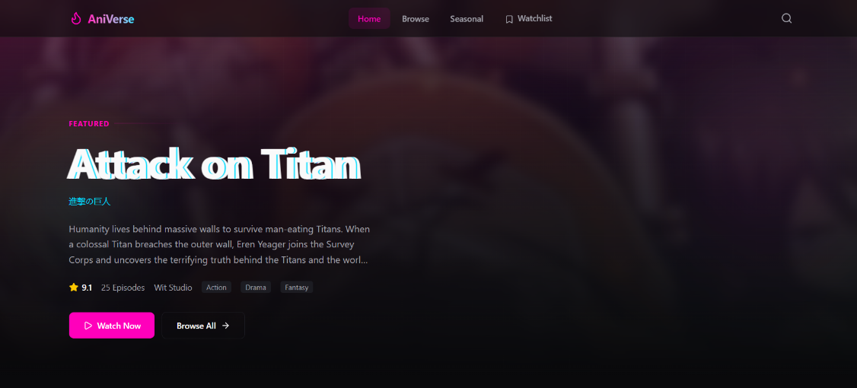
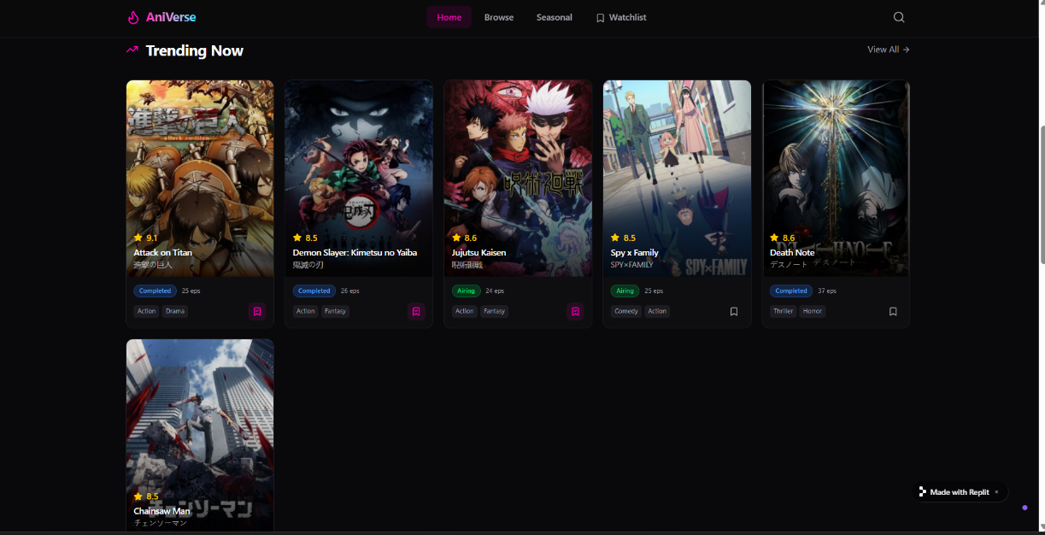

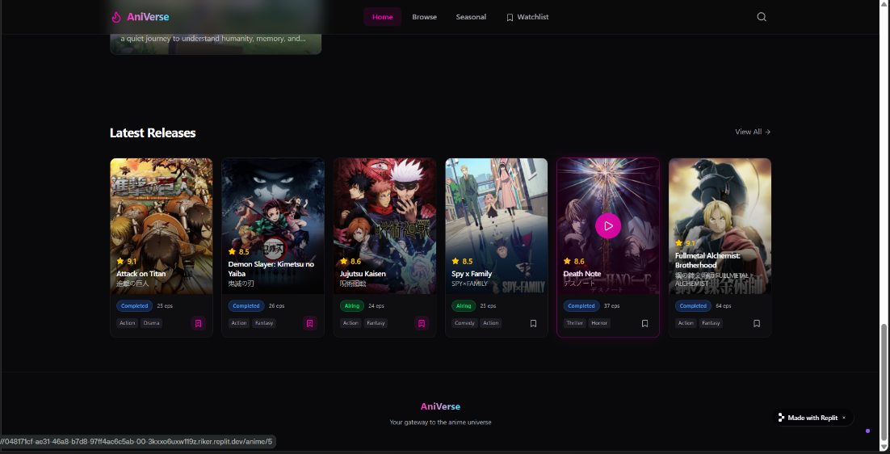
Browser Page:
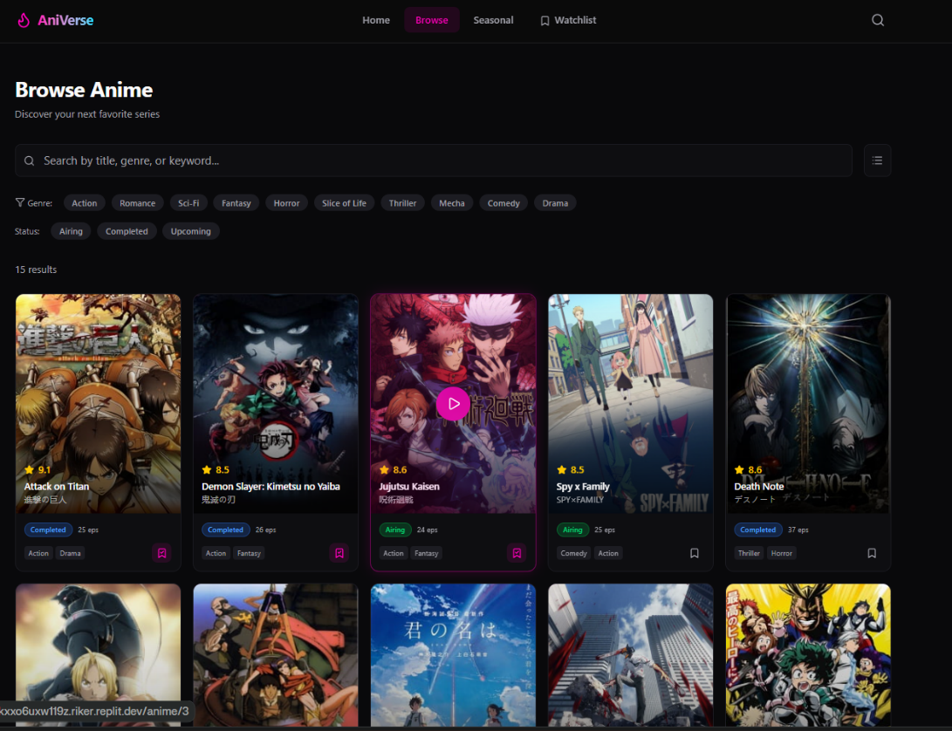

Seasonal page:-
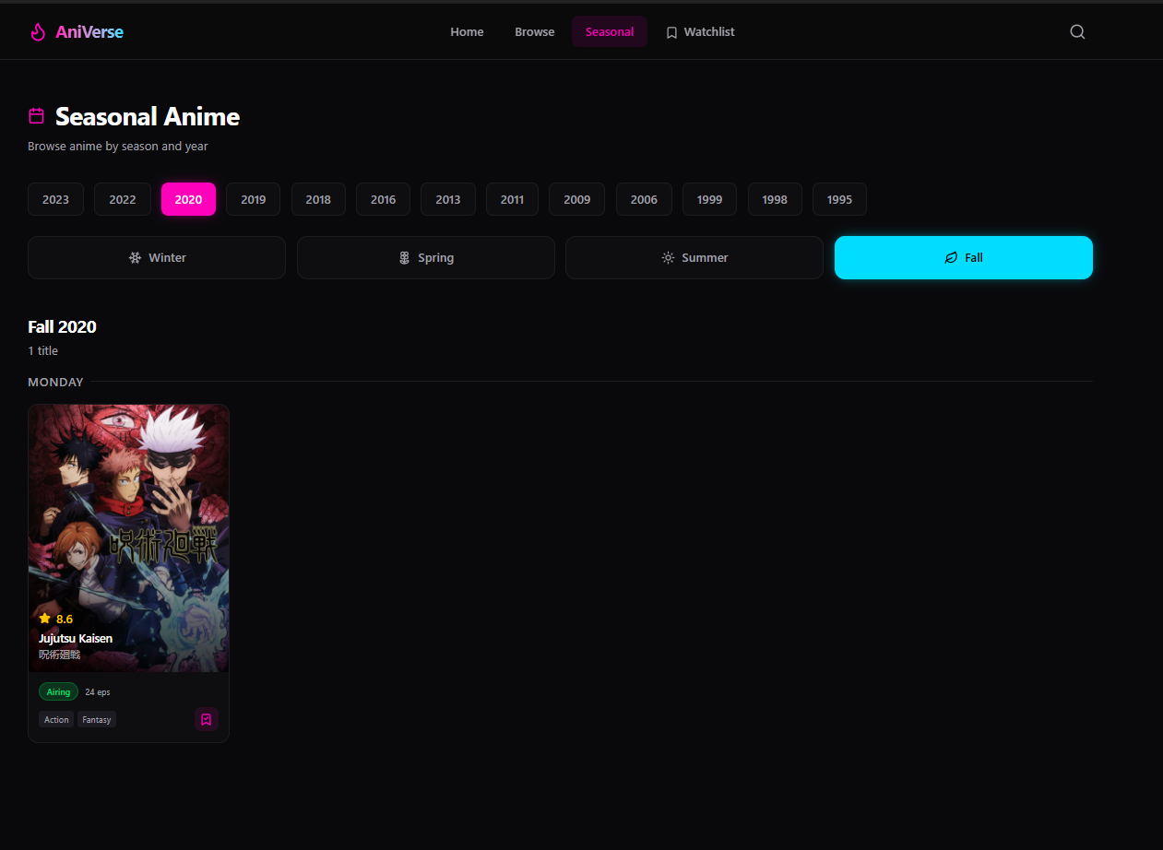
WatchList:
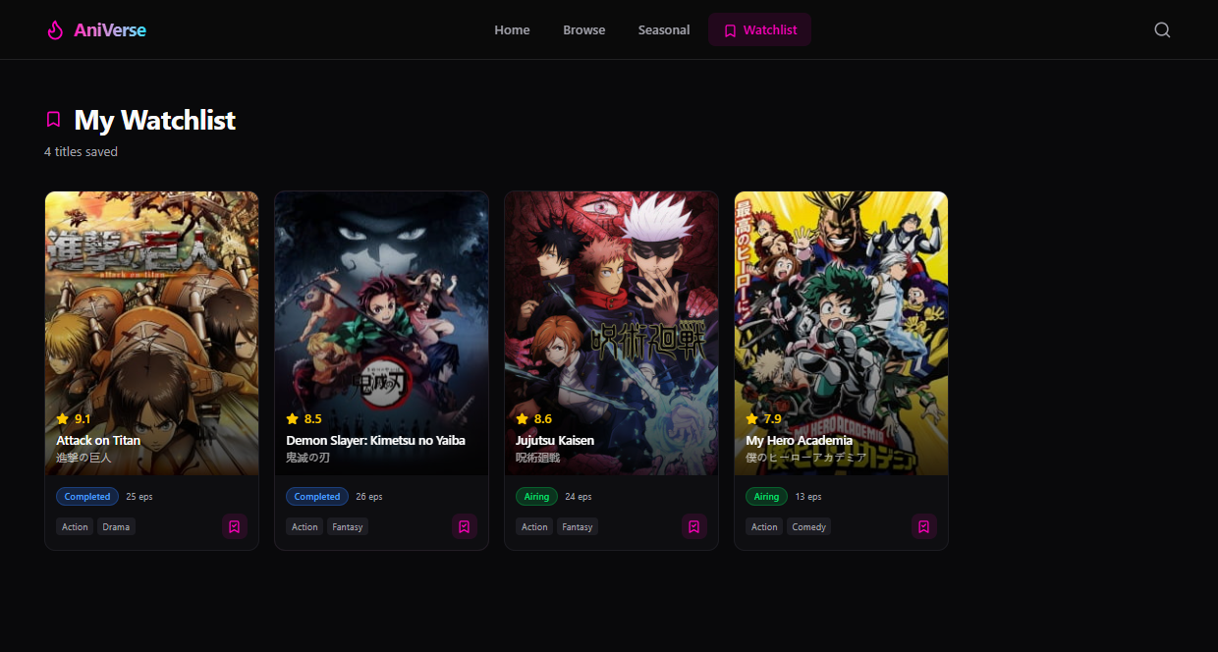

Task 5 – Deployment
• Deploy the app using Replit hosting or export it to a mobile framework (like Expo for React Native).
• Share the deployment link with peers for testing.
Expected Outcomes:
• Students will understand how to use Replit for mobile app development.
• Ability to build a basic functional mobile app with UI, navigation, and user interaction.
• Experience in AI-assisted coding, debugging, and documentation for mobile applications.
Prompt:-
deployed the application using Replit hosting and generated a shareable link. After deployment, I tested the app again to confirm that all features were working correctly. I then shared the link with others to gather feedback. This step gave me a complete understanding of how to make an app accessible online.
Ouptut:-
Home page:
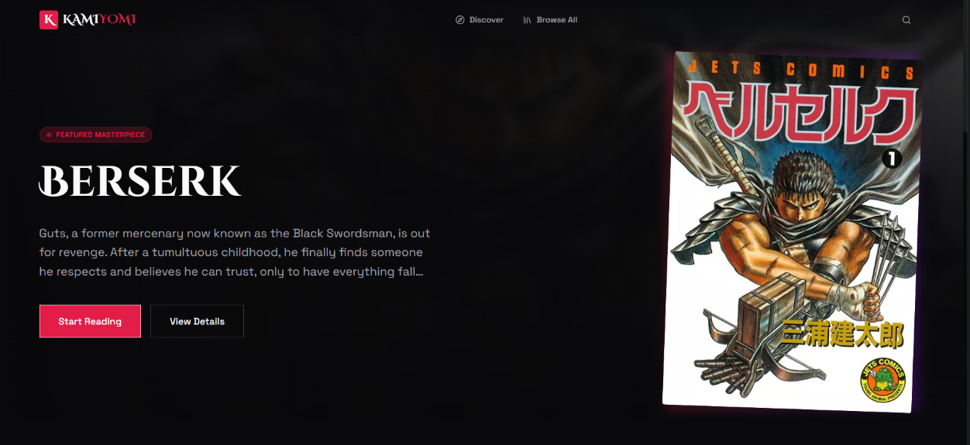
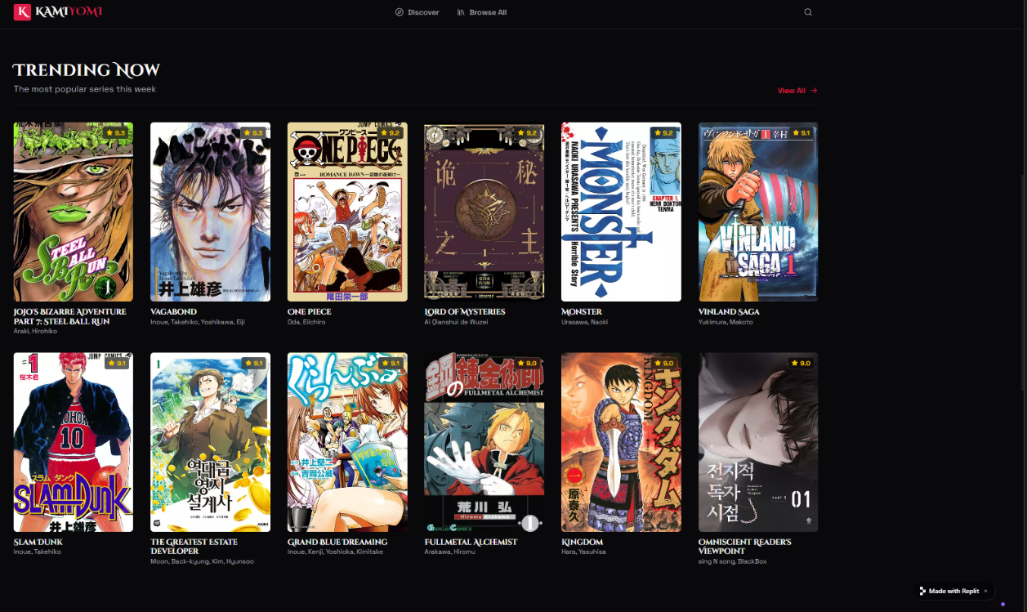
Discover page:
